Project Development - Delivery Of Sprint-4

Dataset :
Data are observations or measurements (unprocessed or processed) represented as text, numbers, or multimedia.
A dataset is a structured collection of data generally associated with a unique body of work.

The data are collected from UCI based on the given attributes. The data set has eleven The attributes description is given set is built on both numerical attribute such as total bilirubin, direct bilirubin, age, gender, total proteins, albumin, albumin and globulin ratio which is the symptoms of liver disease. liver instances. The Dataset used in the study consist of 416 are positively tested. Class value “ liver disease. The entire attribute and their types are given in Table 1. shown in Fig1 which is loaded in the Weka tool. Attribute Name Age of the patient Gender of the Patient Total Bilirubin Direct Bilirubin Alkphos Alkaline Phospotase Sgpt Alamine Aminotransferase Total proteins Albumin Albumin and Globulin Ratio Class Fig1: International Journal of Data Mining & Knowledge Management Process (IJDKP) Vol.8, No.2, M level of confidence on the best attribute to split the tree, hence we can number of instances that has used. The data are collected from UCI Machine Learning Repository [13] and it predicts attributes. The data set has eleven attributes which predict the given below. Based on data types the attributes are given and nominal data types. In our study the dataset contains the total bilirubin, direct bilirubin, age, gender, total proteins, albumin, albumin and which is the symptoms of liver disease. The data sets consist of 538 liver and non The Dataset used in the study consist of 167 negative tested for liver disease Class value “Yes” means having liver disease and “No” means negative The entire attribute and their types .

4. EXPERIMENTS AND RESULT:

The comparison of various decision tree algorithms performed on liver disease data is shown in Table 2.Decision Stump hast the highest accuracy rate. The accuracy rate of this algorithm is 70.67%.It is seen that Decision Stump is the most powerful classifier for this example. This result shows that the liver disease of a new patient is predicted successfully with an acceptable ratio 70.67%.Random Tree, LMT and Hoeffding Tree has the accuracy rate as 69.47%, 69.30% and 69.75%.It is also seen that J48 has the worst accuracy rate with 65.69%.The comparison of decision tree algorithm with respect to accuracy shown in Fig2. The comparison of decision tree algorithm with respect to kappa statistics and runtime is shown in Fig3 and Fig4 respectively. REPTree, Random Tree and Decision Tree are faster than other algorithms.LMT algorithm takes a long time even though a small dataset is used. A decision tree is shown in Fig5 which is generated by J48 algorithm. Table 2: Comparing the various decision tree algorithms carried out liver dataset
CONCLUSIONS The study employed some decision tree algorithm such as J48, LMT, Random Forest, Random tree, REPTree, Decision Stump and Hoeffding Tree to predict the liver disease at an earlier stage. These algorithm gives various result based on Accuracy, Mean Absolute Error, Precision, Recall, Kappa statistics and Runtime. These techniques were evaluated and their performance was compared. From the analysis, Decision Stump outperforms well than other algorithms and its achieved accuracy is 70.67%. The performance measure used for comparison are listed in the table (Table 2) The application of Decision tree in predicting liver disease will benefit in managing the health of individuals. However, in future, we will collect the very recent data from various regions across the world for liver disease diagnosis. The results of this study will encourage us to continue developing other advanced decision trees such as CART.
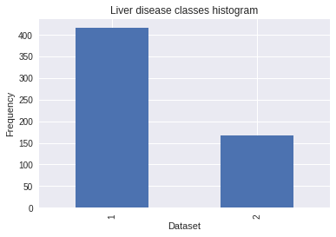

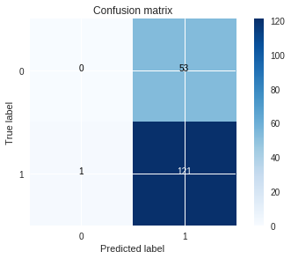
CONCLUSIONS:
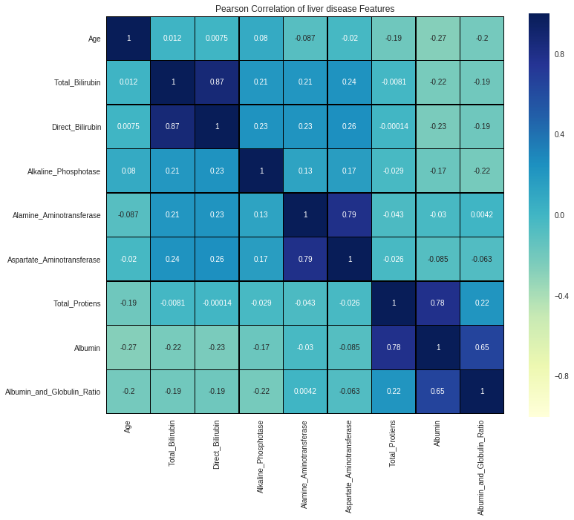

The study employed some decision tree algorithm such as J48, LMT, Random Forest, Random tree, REPTree, Decision Stump and Hoeffding Tree to predict the liver disease at an earlier stage. These algorithm gives various result based on Accuracy, Mean Absolute Error, Precision, Recall, Kappa statistics and Runtime. These techniques were evaluated and their performance was compared. From the analysis, Decision Stump outperforms well than other algorithms and its achieved accuracy is 70.67%. The performance measure used for comparison are listed in the table (Table 2) The application of Decision tree in predicting liver disease will benefit in managing the health of individuals. However, in future, we will collect the very recent data from various regions across the world for liver disease diagnosis. The results of this study will encourage us to continue developing other advanced decision trees such as CART.
The study employed some decision tree algorithm such as J48, LMT, Random Forest, Random tree, REPTree, Decision Stump and Hoeffding Tree to predict the liver disease at an earlier stage. These algorithm gives various result based on Accuracy, Mean Absolute Error, Precision, Recall, Kappa statistics and Runtime. These techniques were evaluated and their performance was compared. From the analysis, Decision Stump outperforms well than other algorithms and its achieved accuracy is 70.67%. The performance measure used for comparison are listed in the table (Table 2) The application of Decision tree in predicting liver disease will benefit in managing the health of individuals. However, in future, we will collect the very recent data from various regions across the world for liver disease diagnosis. The results of this study will encourage us to continue developing other advanced decision trees such as CART.

